Chapter 6: Multiplying Fractions

Using the Algorithm to Solve (Procedure/Follow the Steps)

Step 1

* Turn any mixed numbers into improper fractions
* Turn whole numbers into a fraction by putting a ‘1’ under them



Cross Simplify

Look for common factors to simplify numbers

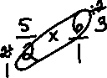

Step 2

* Check if you can cross simplify
* Multiply: Numerator x Numerator and Denominator x Denominator



Step 3

* Turn an improper fraction into a mixed number and check for lowest terms



Show You Know







Note: The order in which we multiply fractions does not change the product, known as *commutative property*.



Multiply Using a Model

Hexagon Trapezoid Rhombus Triangle

= 1 = $\frac{1}{2}$ = $\frac{1}{3}$ = $\frac{1}{6}$

Example of Using a Model

3 x = =

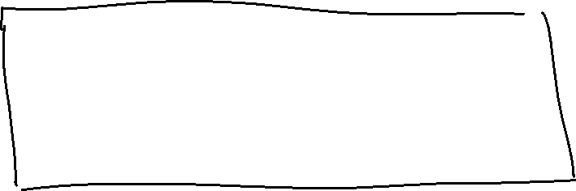

\*\*Multiplication can also be written as repeated addition\*\*

+ + = =

Multiplication Using Number Lines

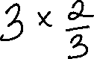

Note: There are 3 “jumps” and each jump is 2/3 along the number line.

